**Table of content**

|  |  |  |
| --- | --- | --- |
| S.No. | Topic | Page No. |
| 1. | Introduction | 2 |
| 2. | E-R diagram | 3 |
| 3. | Queries to use Create Update, Drop, Truncate, Insert, Delete, Alter statements | 4 |
| 4. | To perform SQL Queries by using Between, Not, In, Null, Like | 9 |
| 5. | To perform SQL Queries by using Distinct, Where, Order by, Group by, Having | 12 |
| 6. | To create the view, execute and verify the various operations as view | 16 |
| 7. | To execute and verify the SQL commands for various join operation | 18 |

**Introduction**

This software project is aimed to keep record of customer transactions in the bank and to build organic and optimal system of interaction between the elements of banking mechanism with a view to profit.

Successful optimization of the "profitability-risk" ratio in a bank lending operations is largely determined by the use of effective methods of bank management.

This system can be used for building application that stores data of various banks, their branches and clients and can help to keep track of various transactions in a secured manner.

**E-R DIAGRAM**

has

Maintains

Account

Bank

Branch

M 1

1 M

**Queries to use Create Update, Drop, Truncate, Insert, Delete, Alter statements**

* Create Database

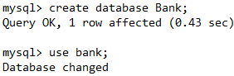

* Create Table

Table 1:

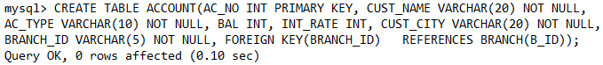

Table 2:



Table 3:

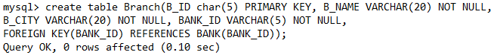

* Table Structure

Table 1:

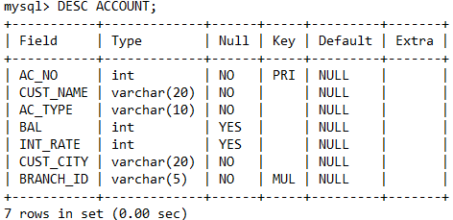

Table 2:

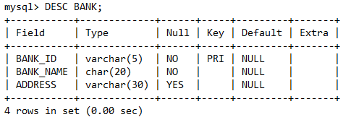

Table 3:

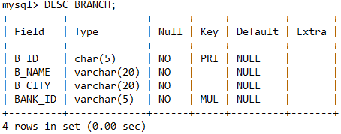

* Insert Values

Table 1:

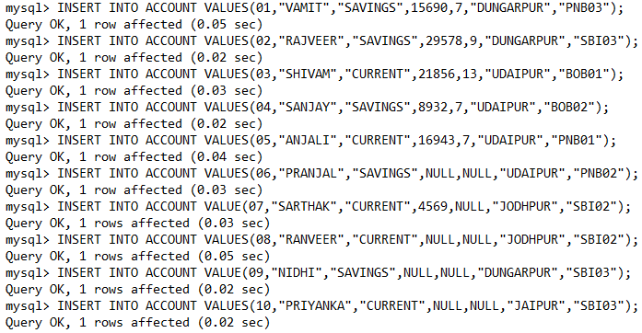

Table 2:

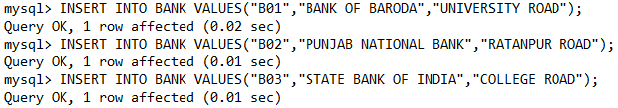

Table 3:

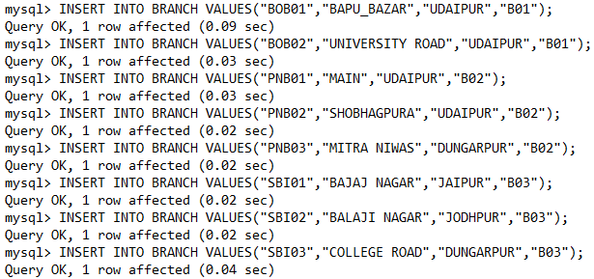

* Show tables

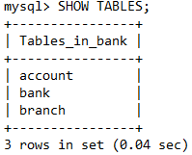

* Drop table



* Update table

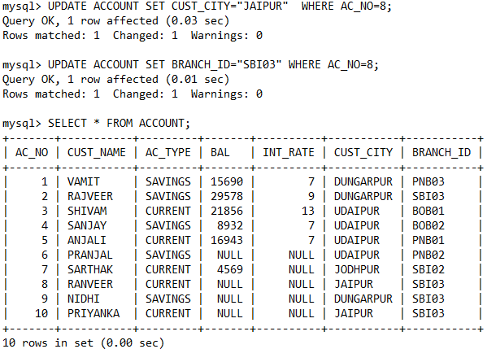

* Tables

Table 1: Account

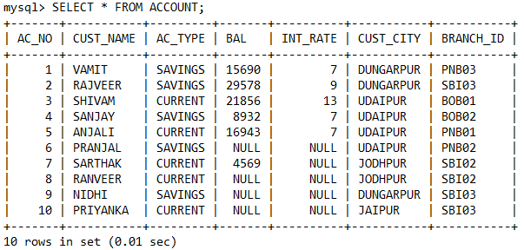

Table 2: Bank

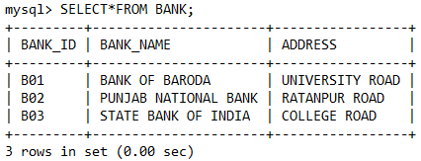

Table 3: Branch

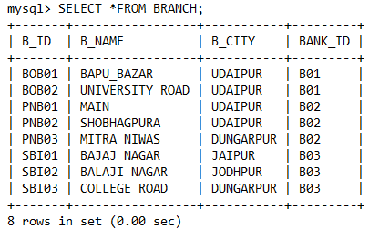

**To perform SQL Queries by using Between, In, Like**

* Between

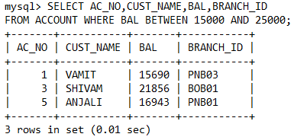

* In

Example 1:

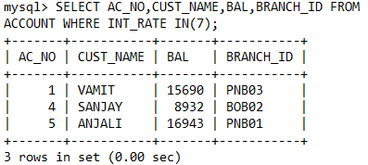

Example 2:

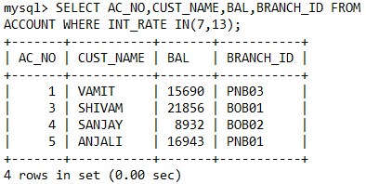

Example 3:

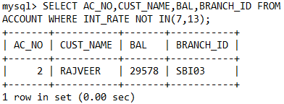

* Like

Example 1:

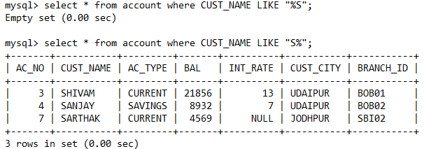

Example 2:

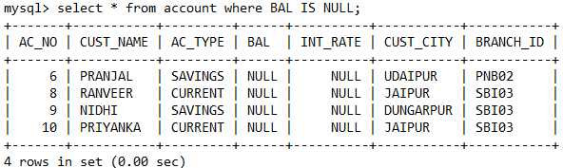

Example 3:

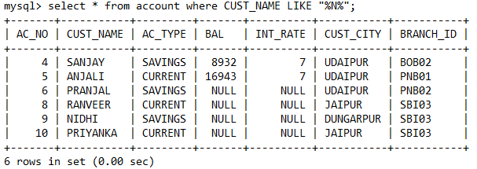

Example 4:

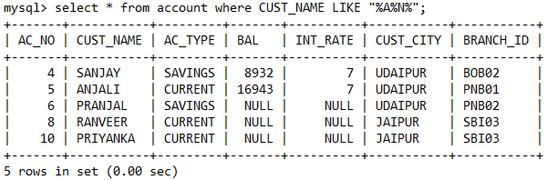

Example 5:

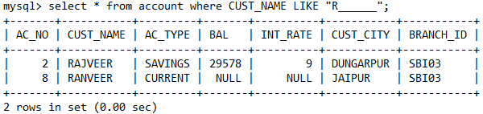

**To perform SQL Queries by using Distinct, Where, Order by, Group by, Having**

* Distinct

Example 1:

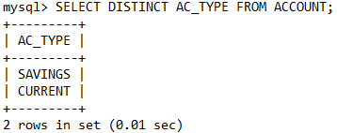

Example 2:

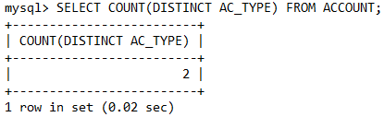

Example 3:

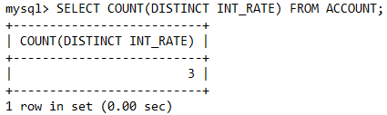

Example 4:

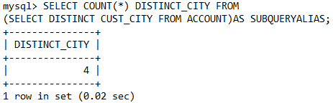

* Where

Example 1:

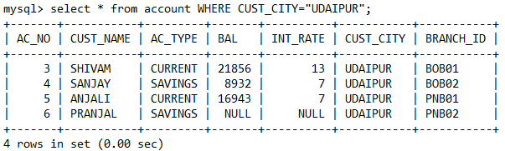

Example 2:

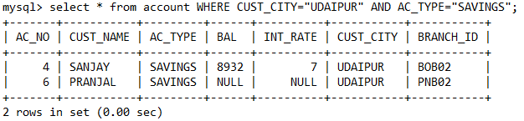

* Order By

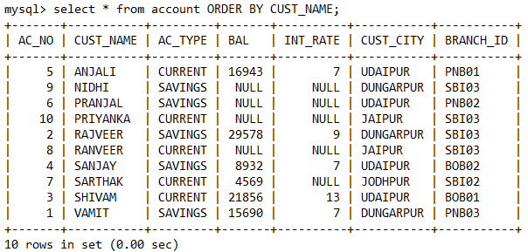

* Order By Desc

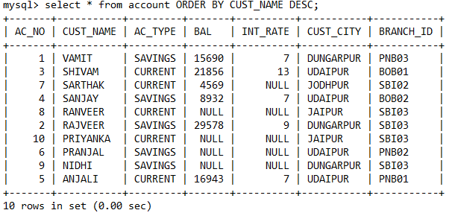

* Group By

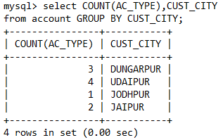

* Group By and Order By together

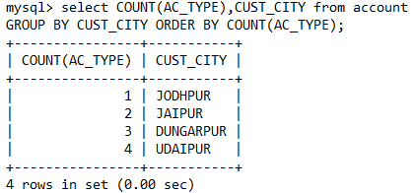

* Having

Example 1:

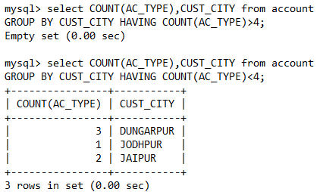

Example 2:

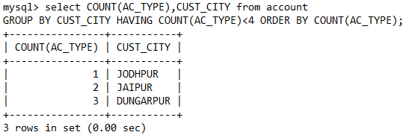

**To create the view, execute and verify the various operations as view**

* Create view

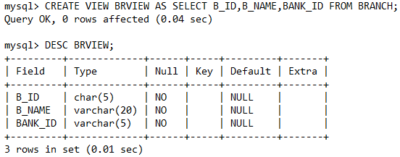

* Insert view

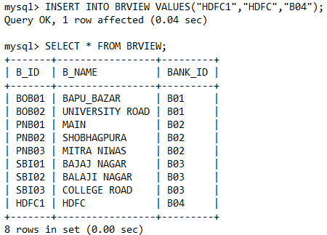

* Delete from view

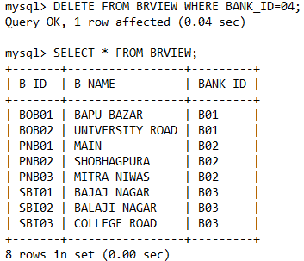

* Drop view

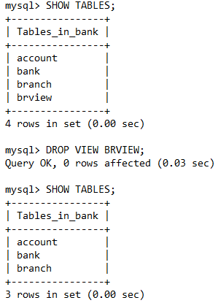

**To execute and verify the SQL commands for various join operation**

* Equi Join

Example 1:

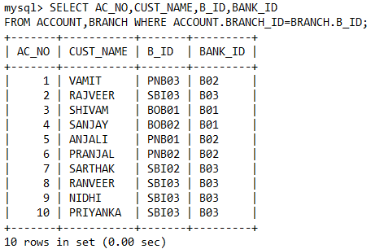

Example 2:

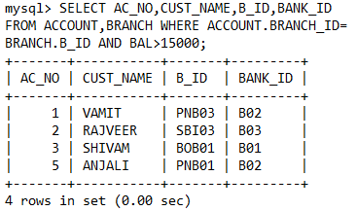

* Cartesian Product

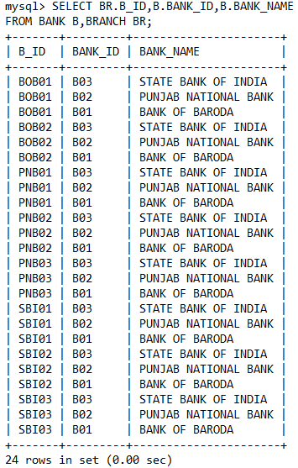

* Inner Join

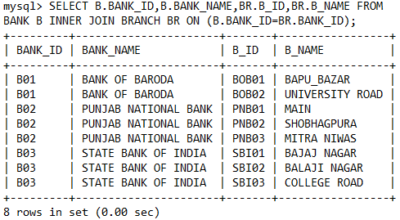

* Natural Join

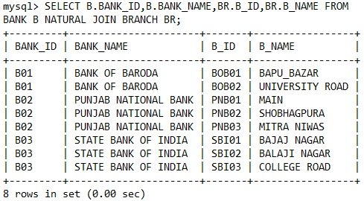

* Cross Join

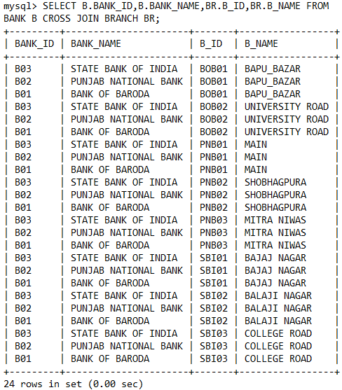

* Right Outer Join

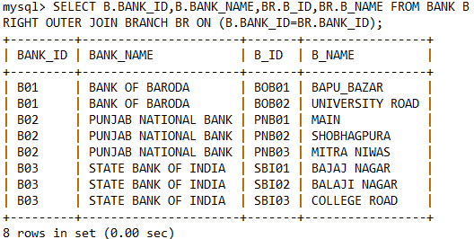

* Left Outer Join

